Tips for Successful Hybrid Working

Pandemic restrictions have eased, and businesses are preparing to return to the office. Many employees have enjoyed the flexibility of working from home. So, it is likely that a “hybrid” model will be the new way of working.
Hybrid working is a mix between remote and office working. Ideally the model provides the best of both worlds. If successful, employees and employers can benefit from the: 1) flexibility of working from home and 2) time to collaborate with colleagues in the office.
In this webinar we present tips for successful hybrid working that will help teams optimise their time and their productivity while achieving a good work-life balance.
Training Options
We offer a range of training option depending on your requirements. In the table below we outline the following:
- 1-hour Top Tips Webinar/Seminar
- 2-Hour Training Session
- 0.5 Day Team Workshop
All training can be delivered in-person or online using your preferred collaboration tool.
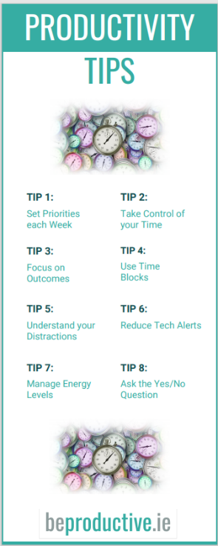
Resources
At all training sessions participants receive a Hybrid Working reference guide plus access to a range of productivity resources such as the Hybrid Working Weekly Planner and the Time Blocking tips card.
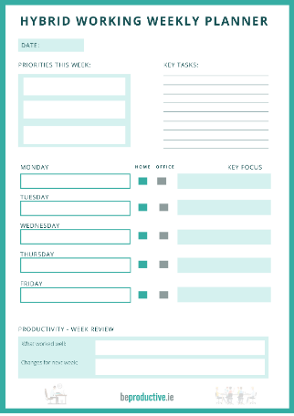
Presenter
This webinar is delivered by Productivity Consultant Moira Dunne.

Successful Hybrid Working

Training Option | Approach
1-hour Top Tips Webinar | The following topics will be covered:  - The importance of resetting before the next phase  - How to plan ahead to get the most from your time  - Individual and team tips to optimise hybrid working  Fee = €300 online, €350 in person
2-hour Top Tips Webinar | The following topics will be covered:  - The importance of resetting before the next phase  - How to plan ahead to get the most from your time  - Individual and team tips to optimise hybrid working  The longer duration allows time for 1) individual planning exercises and 2) group discussion on how to work together effectively in a hybrid model  Fee = €450 online, €500 in person
0.5 Day Team Workshop (3.5 hours) | The following topics will be covered:  - The opportunities and challenges of working in a Hybrid model  - How teams can plan ahead to optimise their time and interaction  - How to optimise hybrid meetings  - The importance of team planning and reporting on a regular basis  The Team Workshop allows time for 1) group discussion and 2) team brainstorming on the best approach to planning, reporting and communicating together in a hybrid model.  Fee = €700 online, €750 in person

Client List

(2016 to Date)

Some Client Feedback

